# CS 255 System Design Document Template

This template lays out all the different sections that you need to complete for Project Two. Each section has guidance to prompt your thinking. You will need to continually reference the interview transcript as you work to make sure that you are addressing your client’s needs. There is no required length for the final document. Instead the goal is to complete each section based on what your client’s needs are. Remove this note when you are finished, and replace all bracketed text with the relevant information.

## UML Diagrams

### UML Use Case Diagram

*[In Module Six, you were asked to complete a use case diagram based on your system design. If you would like to make any adjustments to your diagram, please do so. Please insert your use case diagram here. Check to make sure that you included appropriate components and symbols and that your design meets the client’s needs.]*

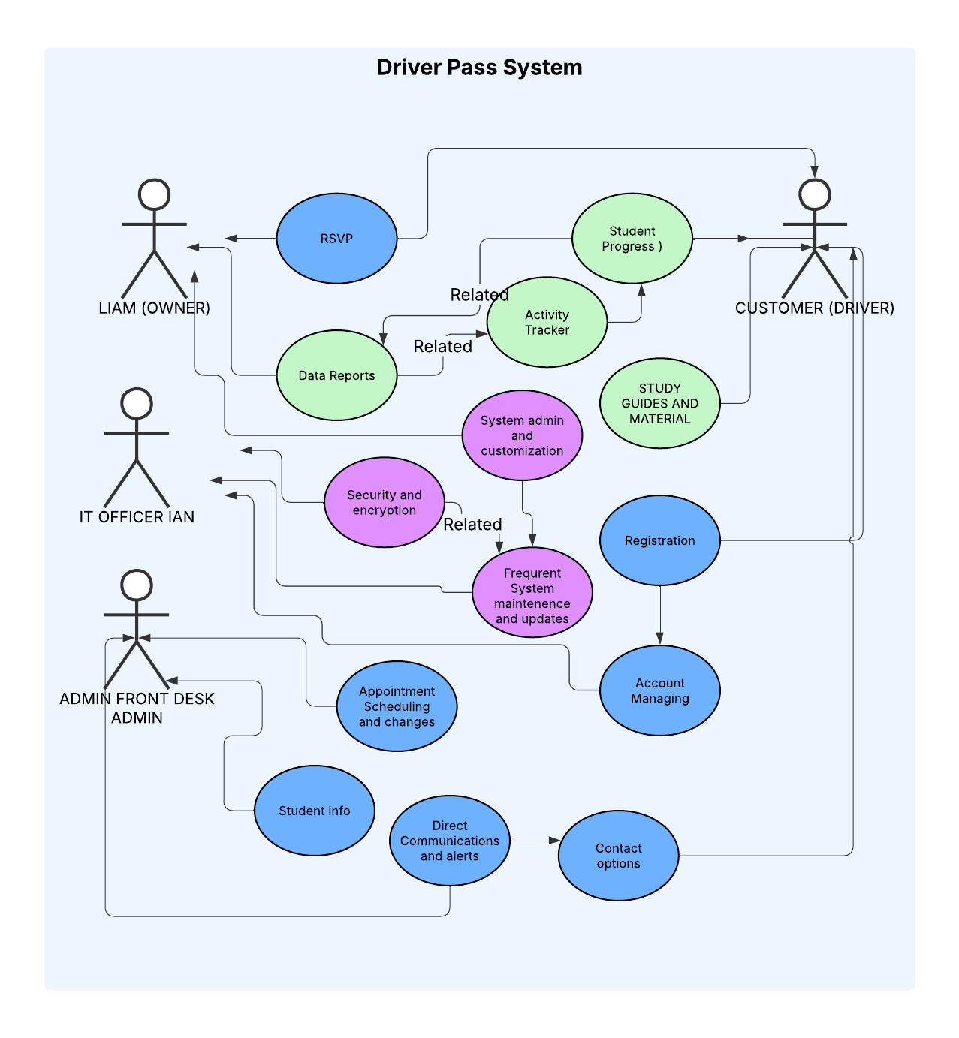

### UML Activity Diagrams

*[You were asked to choose* ***two*** *use cases and create* ***two*** *activity diagrams, one for each use case. Please insert* ***both*** *of your activity diagrams here. Check to make sure that you included appropriate components and symbols and that your design meets the client’s needs.]*

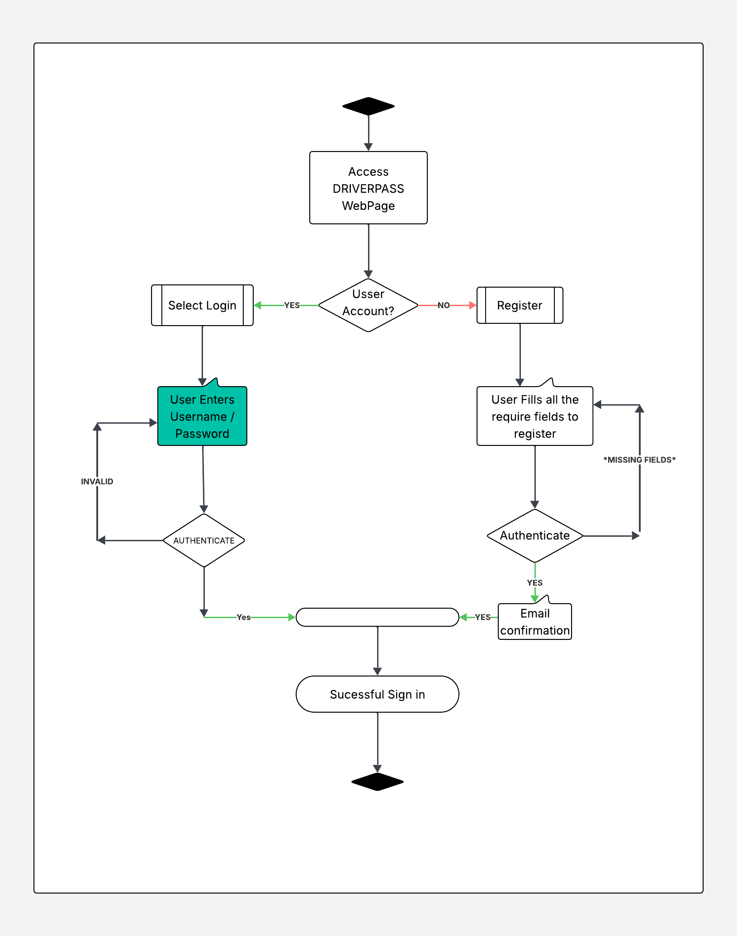

Login/Registration Activity Diagram

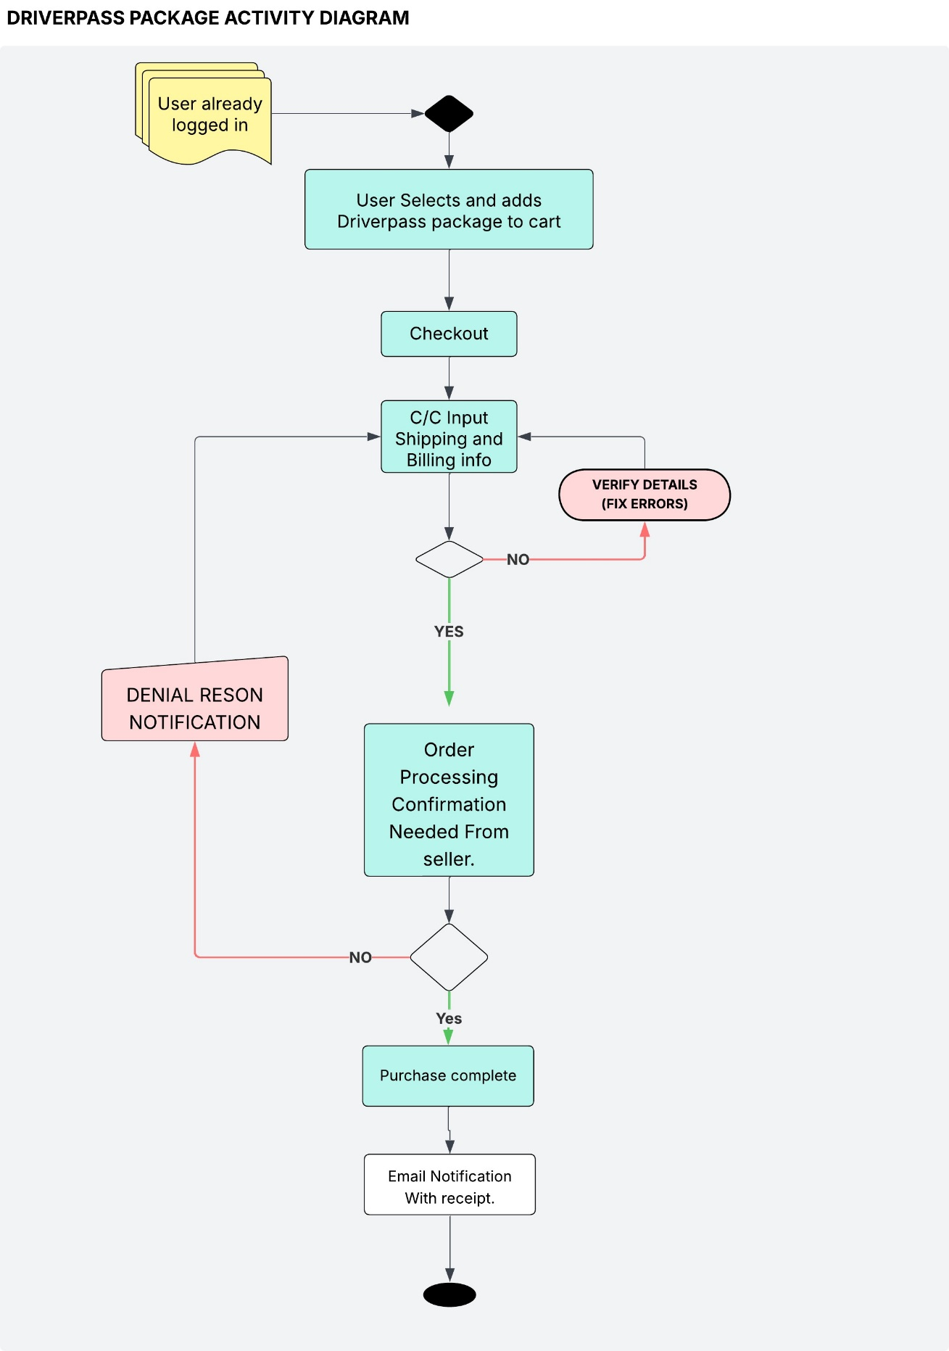

### UML Sequence Diagram

*[You were asked to create a sequence diagram based on* ***one*** *of the use cases you chose. Please insert your sequence diagram here. Check to make sure that you included appropriate components and symbols and that your design meets the client’s needs.]*

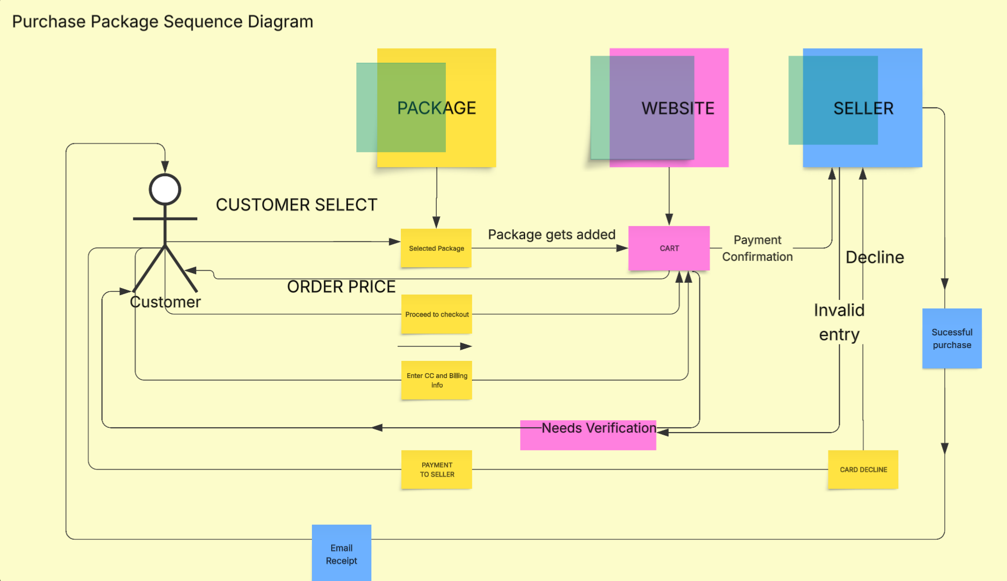

### UML Class Diagram

*[You were asked to create a class diagram based on the different classes and attributes needed for your system design. You are* ***not*** *required to include methods, but you may if you wish. Please insert your class diagram here. Check to make sure that you included appropriate components and symbols and that your design meets the client’s requirements.]*

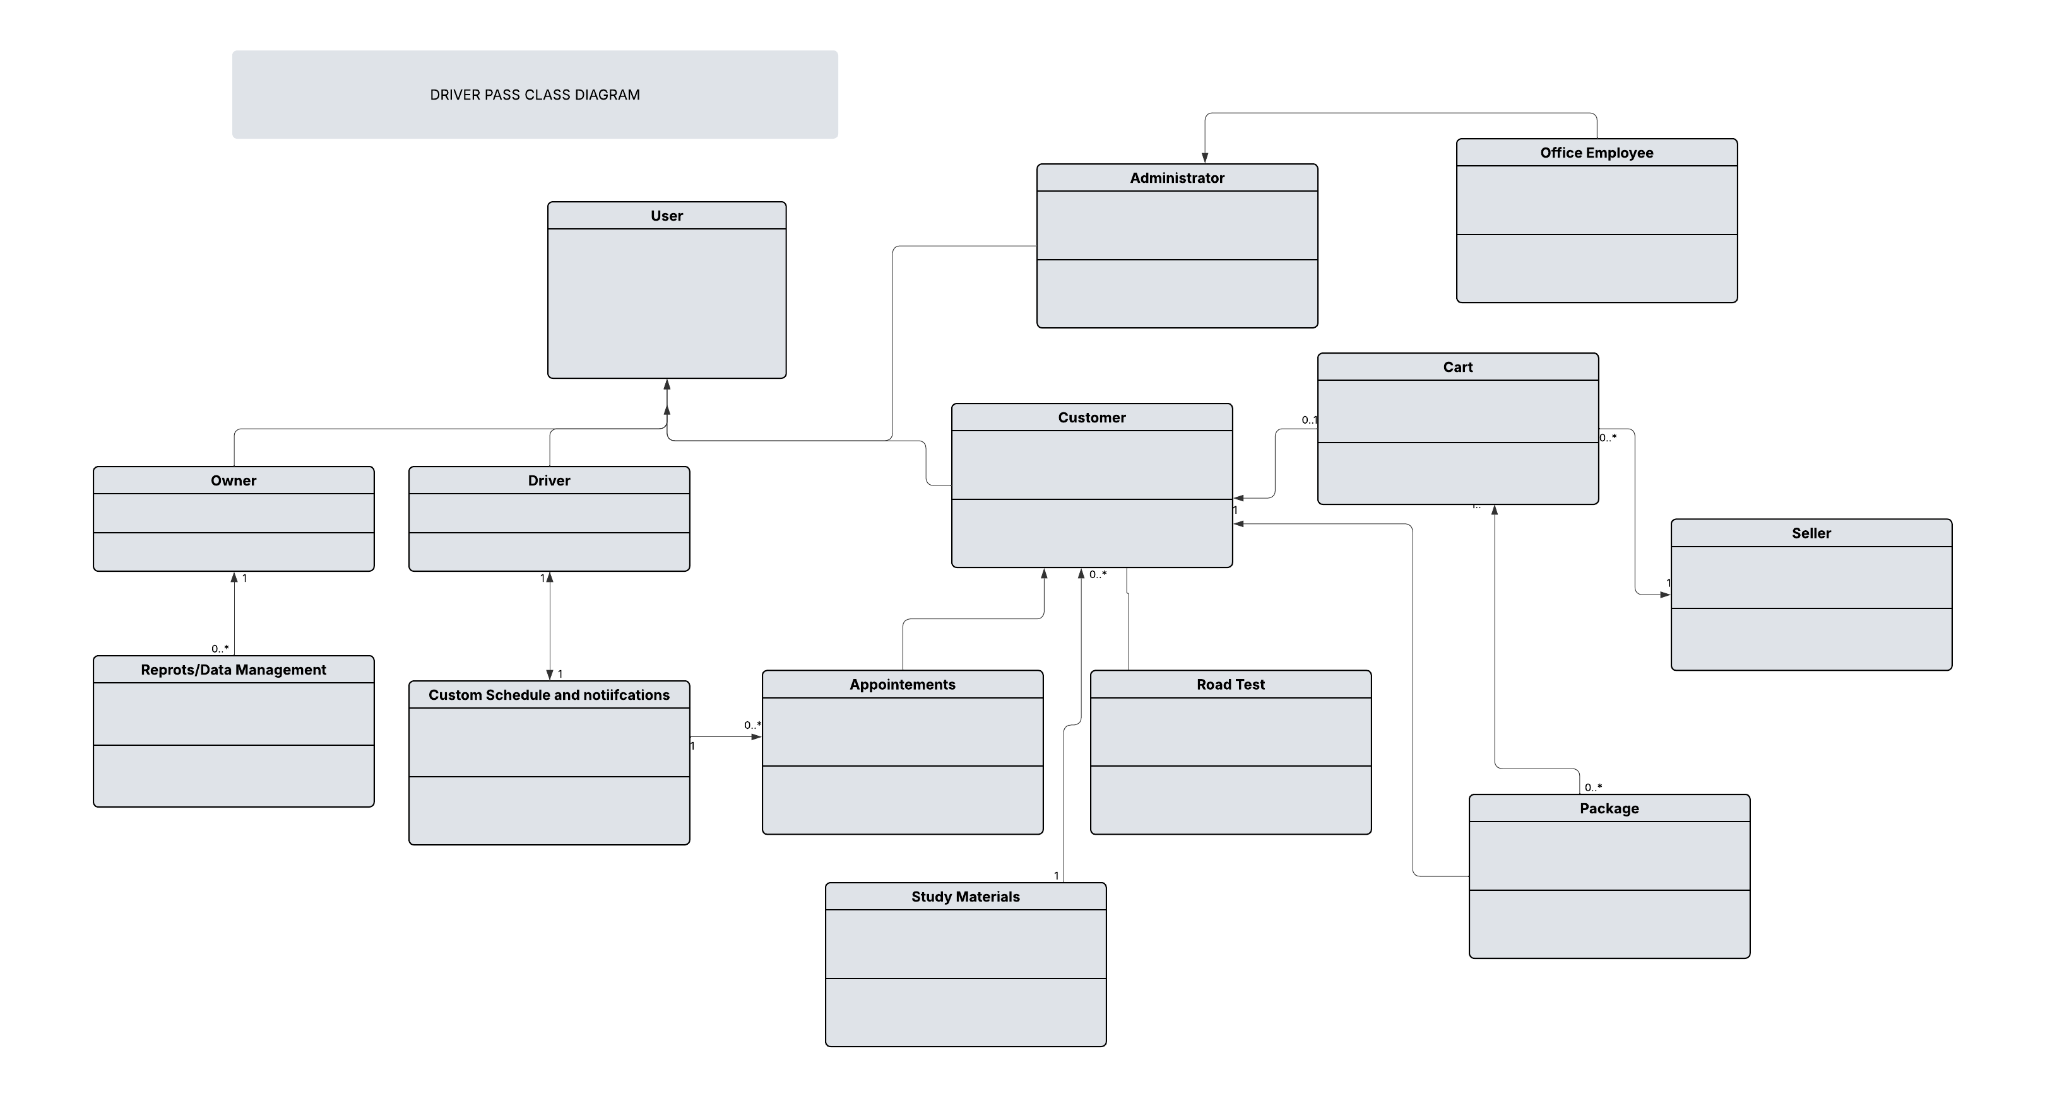

## Technical Requirements

*[Based on the diagrams you have created, describe the technical requirements of your system. These requirements should address the required hardware, software, tools, and infrastructure necessary for your system design.]*

***Hardware Requirements***

* *A* ***dedicated server*** *to host the application and manage traffic efficiently.*
* *A* ***reliable high-speed internet connection*** *to ensure consistent uptime and responsiveness.*
* ***Sufficient storage capacity*** *to maintain both the website files and database records securely.*
* *A* ***computer or mobile device*** *for end users to access the website’s services.*
* *A* ***network firewall*** *to safeguard open ports and prevent unauthorized access.*

***Software Requirements***

* ***Windows Server*** *(recommended), utilizing the latest stable release for optimal performance and compatibility.*
* ***Microsoft SQL Server*** *(recommended) for database management, ensuring data reliability and scalability.*
* ***Backup and recovery software*** *to protect website and database data against potential loss.*
* *A* ***web server platform*** *such as Apache to manage HTTP requests and serve web content.*
* ***Comprehensive security software*** *to detect and prevent malware or other malicious activities.*

***Geographic and Infrastructure Considerations***

* *The* ***website should be accessible throughout the United States*** *to serve the intended user base effectively.*
* *The* ***server and database infrastructure*** *should be securely maintained within a* ***professional data center****.*
* *The* ***server location*** *should be* ***centrally positioned*** *to optimize performance and minimize latency for all users.*